EXPERIMENT- 8

REG- 16BIT0453
NAME – KRISHNA KUMAR MAHTO

Code:

#include<stdio.h>
#include<stdlib.h>

#define MAX_BLOCKS 10
#define MAX_FILES 20

const int hole_size = 1024;
int files[MAX_FILES];

void memory_status(const int blocks[],int blocks_num)
{
int i;

puts("Memory status: ");
for(i=0;i<blocks_num;i++)
printf("| %d ",blocks[i]);
puts("|");
}

void first_fit(int blocks[],const int blocks_num,const int files_num)
{
int i,j,allocated,unallocated[MAX_FILES],unalloc_count=0,ext_fragmentation=0;

for(i=0;i<files_num;i++)
{
allocated = 0;
for(j=0;j<blocks_num;j++)
{
if(files[i] <= blocks[j])
{
blocks[j] -= files[i];
allocated = 1;
printf("\nFile %d allocated in block %d\n",i,j);
break;
}
else
continue;
}
if(allocated == 0)
{
printf("\nFile %d Cannot be allocated\n",i);
unallocated[unalloc_count++] = files[i];
}
}
memory_status(blocks,blocks_num);

puts("External fragmentation");
for(i=0;i<blocks_num;i++)
ext_fragmentation += blocks[i];
printf("%d\n",ext_fragmentation);
}

void best_fit(int blocks[],const int blocks_num,const int files_num)
{
int i,j,allocated,unallocated[MAX_FILES],block_found,unalloc_count=0,ext_fragmentation=0;
int best_index,block_file_diff;

for(i=0;i<files_num;i++)
{
block_file_diff = 1024; //arbitrarily large number assigned so that the first comparision in following loop becomes true
allocated = 0;
block_found = 0;
for(j=0;j<blocks_num;j++)
{
if(files[i] <= blocks[j])
{
block_found = 1;
if(block_file_diff > (blocks[j]-files[i]))
{
block_file_diff = blocks[j] - files[i];
best_index = j;
continue;
}
}
}
if(block_found == 0)
{
printf("\nFile %d cannot be allocated.\n",i);
continue;
}
else
{
blocks[best_index] -= files[i];
allocated = 1;
printf("\nFile %d allocated in block %d\n",i,best_index);
}

memory_status(blocks,blocks_num);
}

puts("External fragmentation");
for(i=0;i<blocks_num;i++)
ext_fragmentation += blocks[i];
printf("%d\n",ext_fragmentation);
}

void worst_fit(int blocks[],const int blocks_num,const int files_num)
{
int i,j,allocated,unallocated[MAX_FILES],block_found,unalloc_count=0,ext_fragmentation=0;
int worst_index,block_file_diff;

for(i=0;i<files_num;i++)
{
block_file_diff = -1; //arbitrarily small number assigned so that the first comparision in following loop becomes true
allocated = 0;
block_found = 0;
for(j=0;j<blocks_num;j++)
{
if(files[i] <= blocks[j])
{
block_found = 1;
if(block_file_diff < (blocks[j]-files[i]))
{
block_file_diff = blocks[j] - files[i];
worst_index = j;
continue;
}
}
}
if(block_found == 0)
{
printf("\nFile %d cannot be allocated.\n",i);
continue;
}
else
{
blocks[worst_index] -= files[i];
allocated = 1;
printf("\nFile %d allocated in block %d\n",i,worst_index);
}

memory_status(blocks,blocks_num);
}

puts("External fragmentation");
for(i=0;i<blocks_num;i++)
ext_fragmentation += blocks[i];
printf("%d\n",ext_fragmentation);
}

int main(int argc,char *argv)
{
int blocks[MAX_BLOCKS];
int blocks_num,choice,blocks_sum=0,files_num,i;

puts("Enter the number of blocks: ");
scanf("%d",&blocks_num);
puts("");

puts("Enter block sizes:");
for(i=0;i<blocks_num && blocks_sum <= hole_size;i++)
{
if(i == blocks_num-1)
{
blocks[i] = hole_size - blocks_sum; //fill the last block automatically
break;
}

scanf("%d",&blocks[i]);
blocks_sum += blocks[i];
}
puts("");

if(blocks_sum > hole_size)
{
printf("Hole size is only: %d\n",hole_size);
exit(0);
}
puts("");

memory_status(blocks,blocks_num);

puts("Enter the number of files");
scanf("%d",&files_num);
puts("");

puts("Enter the file sizes: ");
for(i=0;i<files_num;i++)
scanf("%d",&files[i]);
puts("");

puts("Which algorithm?\n1. First fit\n2. Best fit\n3. Worst fit");
scanf("%d",&choice);
puts("");

switch(choice)
{
case 1:
first_fit(blocks,blocks_num,files_num);
break;

case 2:
best_fit(blocks,blocks_num,files_num);
break;

case 3:
worst_fit(blocks,blocks_num,files_num);
break;
}

return 0;
}

OUTPUT:

FIRST FIT:

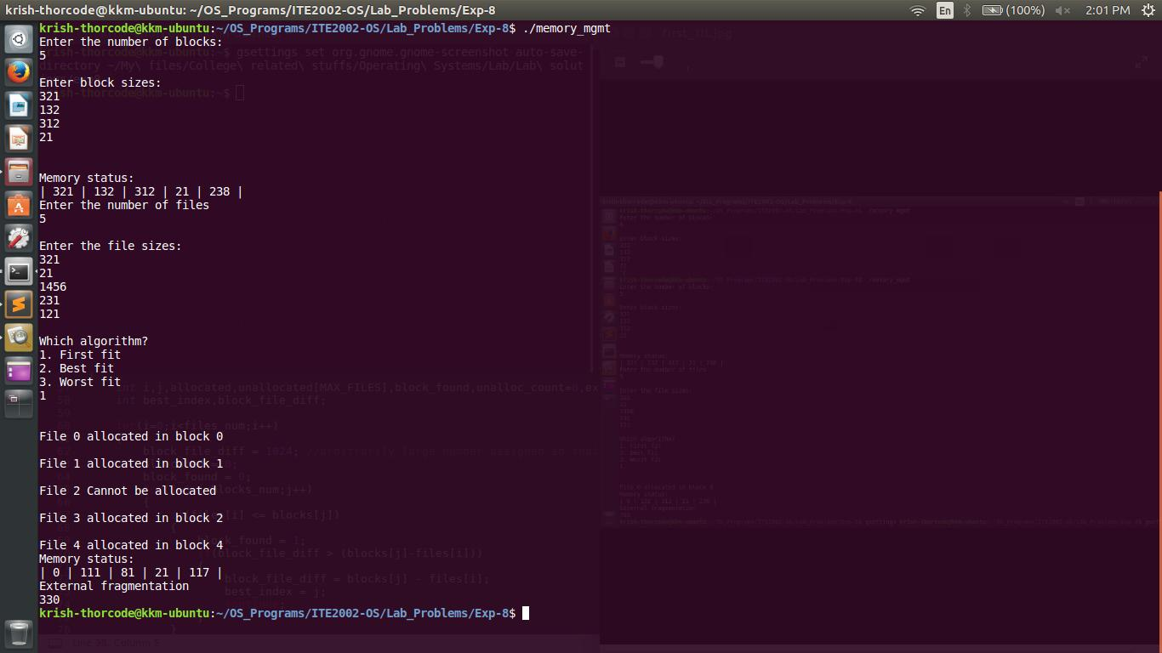

BEST FIT:
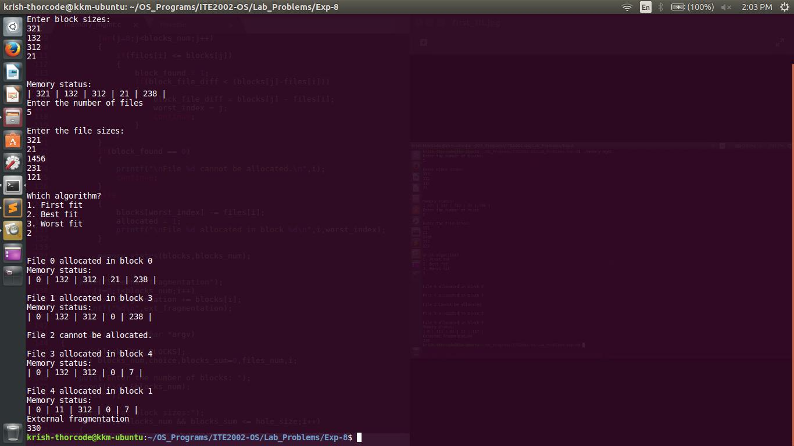

WORST FIT:

